Form completed by: Name (CAPS):_____________________Signature:__________________ Date:____/___/_____

MCRN (if applicable):______________ Contact number(s):______________________________________________

**Referral Form to the Specialist Liver Cancer Service at SVUH**

Liver Cancer Services, Liver Unit, St. Vincent’s University Hospital, Elm Park, Dublin 4, D04T6F4

Email: [livercancer@svhg.ie](mailto:livercancer@svhg.ie), Tel: 012213671, or switchboard (01) 2214000, Bleep 477

**Reason for Referral**

1) MDT Discussion only  2) MDT discussion and specialist clinic review 

3) MDT discussion, clinic review and treatment  4) MDT discussion and ongoing care 

**Patient Details**

First Name: ___________ Surname:_______________

Address: ______________________________________

_____________________________________________

DOB: ___/____/_____ Hospital No: _______________

Tel: ___________________ Mobile: _______________

Male Female Wheelchair assistance: Y / N

First language: __________ Interpreter required: Y / N

**Consultant & GP Details**

Referring Consultant: ___________________________

MCRN: ______________ Hospital: ________________

_____________________________________________

Tel (mobile): _____________ Email: _______________

GP Name: _________________ Tel: ________________

GP Address: ___________________________________

______________________________________________

**Clinical Details**

**Liver lesion identified: On surveillance programme  Incidental pick-up  Symptomatic pick-up **

Working diagnosis: ____________________ Patient aware of diagnosis: Y / N Date of Presentation: ___/___/___

Presenting symptoms: Pain Weight loss Nausea / vomiting Pruritis Jaundice Anaemia

Ascites Hepatic Encephalopathy Haematemesis / PR bleeding Other:________________________

Patient weight: ____kg Weight loss: ____kg Height: ____ BMI: ____ Smoker: Y / N Ex-smoker: Y / N

Liver Disease: Y / N, ALD Fatty Liver HCV HBV AIH PSC PBC Other:__________ Cirrhosis: Y / N MELD score: _______ CTP Score: _______ ECOG: _______

Alcohol: Y / N, Units per week: _______ Abstinent: Y / N, How long:_______ PEth level: _______

Medical / Surgical history:________________________________________________________________________

Medications: __________________________________________________________________________________

Anticoagulants / Antiplatelets: Y / N Allergies: Y / N Details: ______________________________________

















**Investigations**

Bloods*: (please include) FBC U&E LFTs Coag AFP Ca 19.9

|  |  |  |  |
| --- | --- | --- | --- |
| INVESTIGATION | HOSPITAL | DATE | SENT (√) |
| 4 phase CT Liver* |  |  |  |
| MRI Liver Gadolinium* |  |  |  |
| MRI Liver Primovist |  |  |  |
| CT Thorax |  |  |  |
| CT Abdomen / Pelvis |  |  |  |
| Cholangiography |  |  |  |
| Liver lesion biopsy |  |  |  |
| Other: |  |  |  |

Please send completed referral form with Liver Cancer MDT Coordinator, Liver Unit, St. Vincent’s University

minimum dataset* (overleaf) for discussion to: Hospital, Elm Park, Dublin 4. Email: [livermedmdtt@svhg.ie](mailto:livermedmdtt@svhg.ie)

Please send Pathology Dr. Niamh Nolan, Dept. of Pathology,

(**slides, blocks and reports**) to: St. Vincent’s University Hospital, Elm Park, Dublin 4













**Liver Cancer Referral Pathway & Timeline**

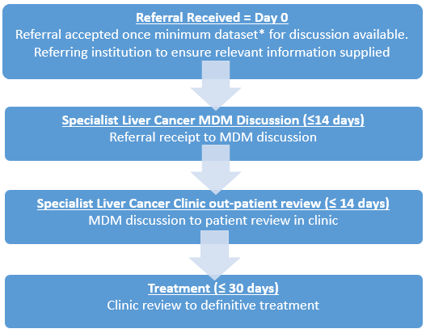

***Thank you for forwarding completed forms and results, failure to provide all the relevant information will cause delays for your patient’s case discussion.***

**\*Minimum dataset required for discussion**

1. Completed referral form (overleaf)
2. Multiphasic liver imaging:

(a) 4 phase CT Liver¹ ***OR***

(b) MRI Liver with contrast² (***preferably*** an extracellular agent)

with the scan report

1. Bloods: FBC, U&E, LFT, INR, AFP and Ca 19.9
2. Histology not essential, but if available please send for review

.

**²MRI Liver with Contrast Protocol, SVUH**

Recommended Equipment:

* 1.5T or 3T
* Torso phased-array coil

Recommended Contrast (preferably an extracellular agent):

* MRI with extracellular agents (ECA) e.g Clariscan (2mls/sec)
* MRI with hepatobiliary agents (HBA) e.g. Primovist (1mls/sec)

Required Images:

* Localiser
* T2_Coronal e.g. Trufi
* Unenhanced T1-weighted OP and IP imaging in axial plane e.g. fl2d
* T2-weighted imaging with Fat Saturation in axial plane e.g. blade_fs
* T2-weighted & long t2-weighted in axial plane e.g. Haste
* Non-contrast T1-weighted imaging with Fat Saturation in axial plane e.g. Vibe_FS
* Post contrast T1-weighted imaging with Fat Saturation in axial plane e.g. Vibe_FS:
* Arterial phase (late arterial phase strongly preferred) – subtraction performed
  + Portal venous phase – subtraction performed
  + Delayed phase – subtraction performed
* DWI imaging in axial plane
* 5 min delayed T1-weighted imaging with Fat Saturation in axial plane e.g. Vibe_FS
* Hepatobiliary agent – 20mins delayed T1-weighted imaging with Fat Saturation in axial plane

**¹4 Phase CT Liver Protocol, SVUH**

Oral Contrast: None required

IV Contrast: 130-150mls Omnipaque 350mg l/ml at 4mls / sec

Four Phases:

1. Non Contrast Liver
2. Late arterial phase liver

Timing: Bolus tracking in the aorta at the level of the SMA (L1), scan 15 seconds after the aorta reaches 100HU. Aim to scan 35-40 secs post contrast

1. Portal venous phase diaphragm to iliac crest

Timing: 65-70 seconds post contrast injection

1. Delayed phase Liver

Timing 5 minutes post contrast injection

Reconstruction: All phases should be reconstructed in 1mm axial slices