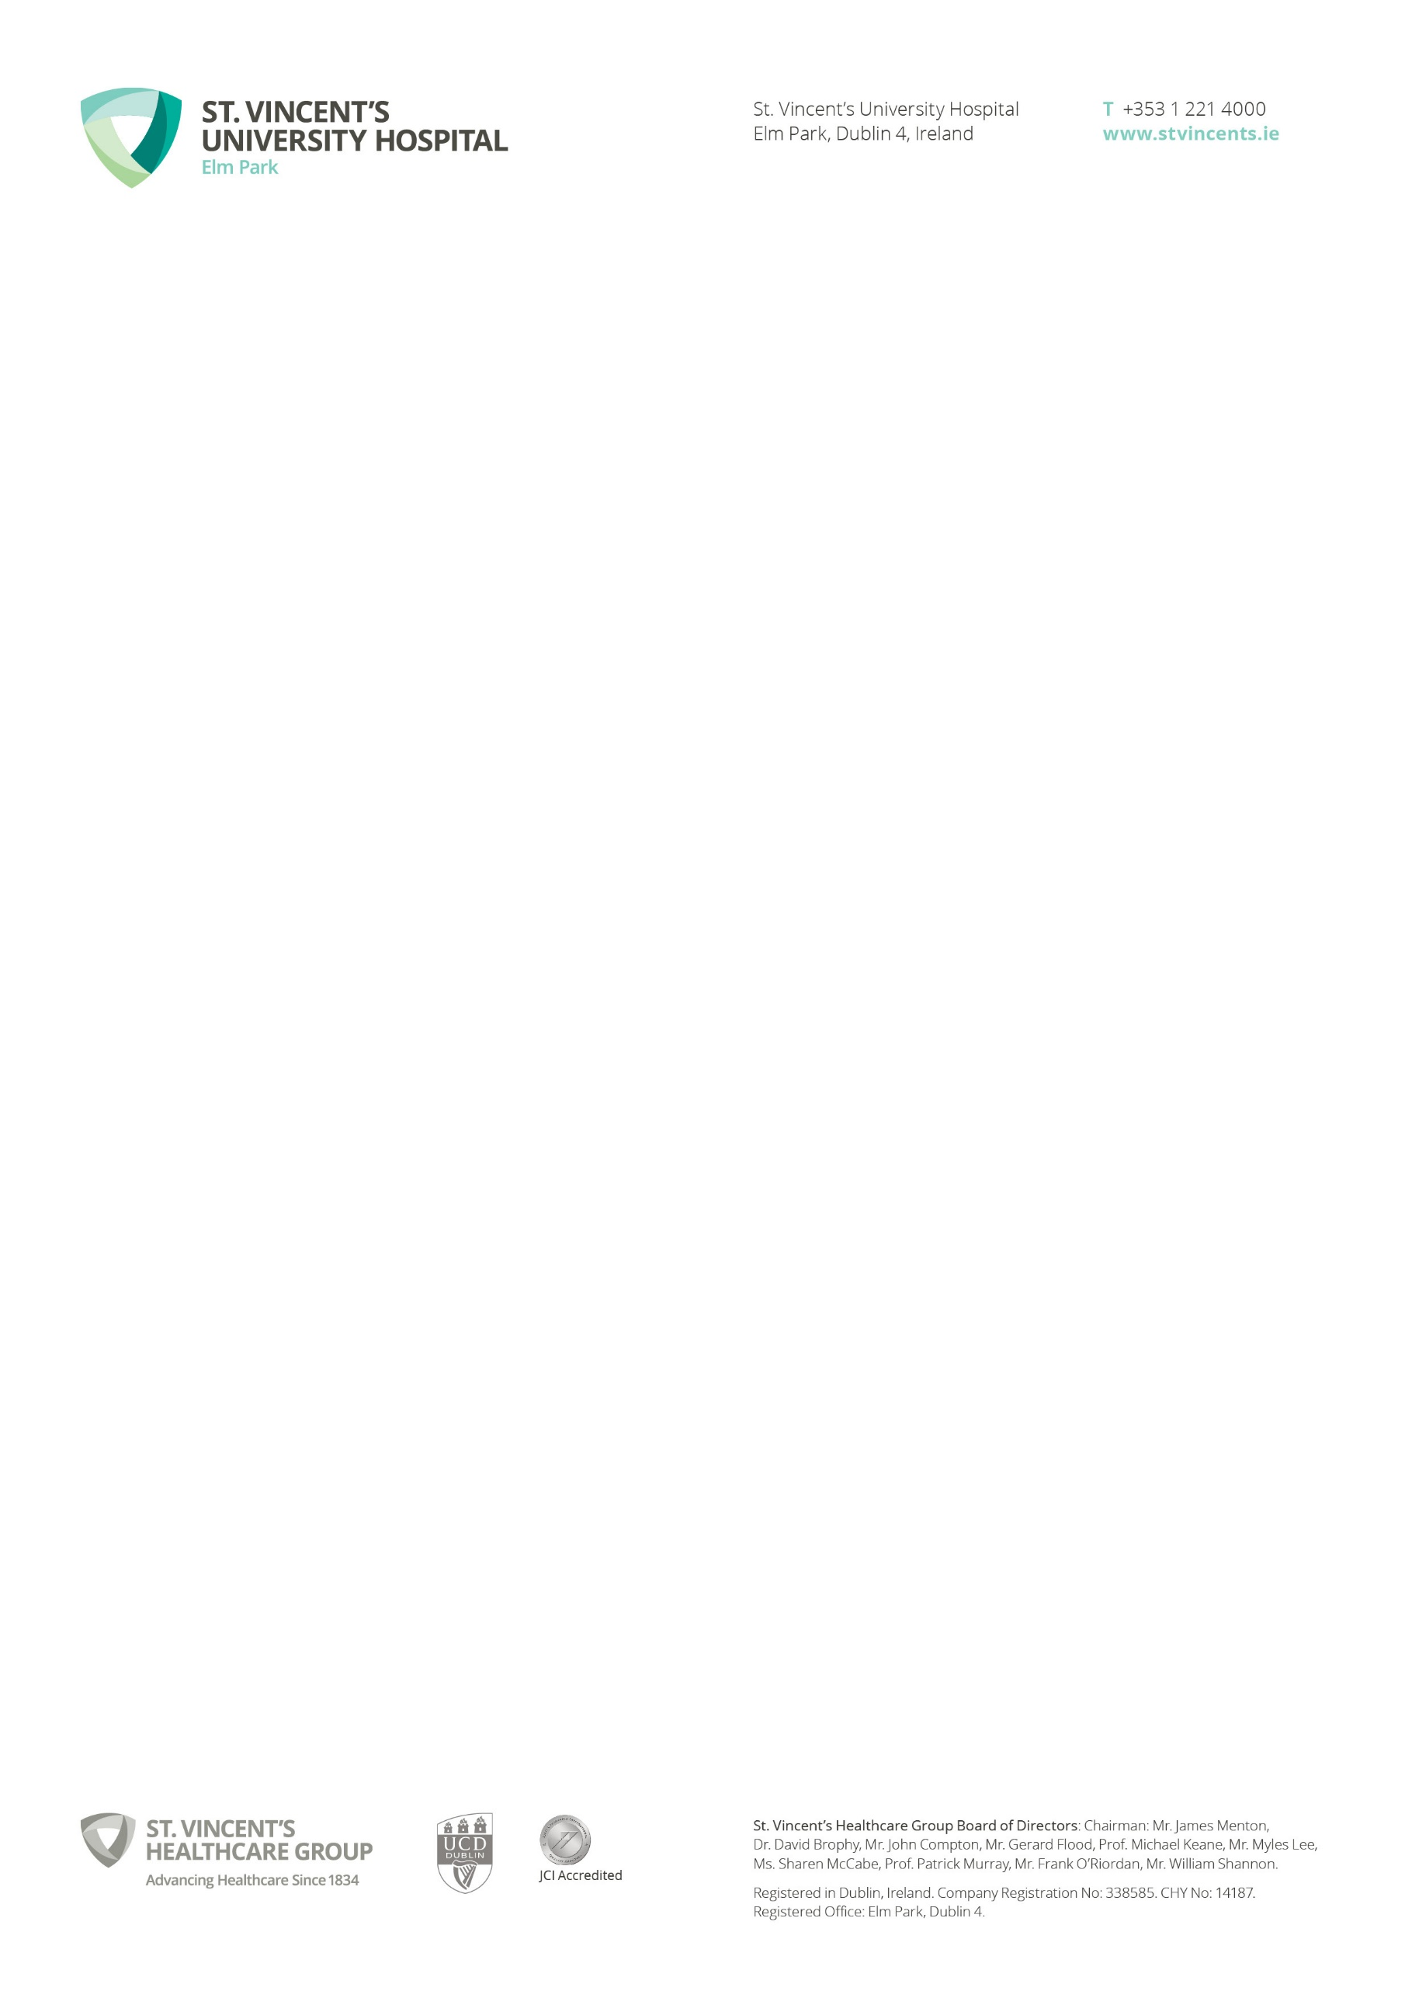

**CONFIDENTIALITY & DATA PROTECTION**

# INTRODUCTION

* 1. This Participant Information and Consent Form provides guidance and information to **[Insert Study name]** research participants regarding the processing of the research participants’ personal data. St. Vincent’s University Hospital is committed to protecting and respecting your privacy. This Participant Information and Consent Form together sets out the basis on which any personal data we collect from you or that you provide to us will be processed by us an independent data controller. Please read this Participant Information and Consent Form carefully to understand our treatment and use of your personal data.
  2. The processing of your personal data will be in compliance with the Data Protection Acts 1988 to 2018 (as amended) and the General Data Protection Regulation (the “**Data Protection Legislation**”).
  3. Please note that agreeing to participate in a research program with St. Vincent’s University Hospital, you acknowledge that you have read, understood and agree to this Participant Information and Consent Form.

# IDENTITY OF THE CONTROLLER OF PERSONAL INFORMATION

For the purposes of the Data Protection Legislation, St. Vincent’s University Hospital is an independent data controller in the following circumstances:

|  |  |
| --- | --- |
|  | **Company/PI Name:[E.G. - Prof. John Smith]**  **Company/PI Type: [ E.G. - SVUH Employee]**  **Company Registration number:**    **Having its registered office at:** |
|  | **Company/PI Name:**  **Company Type:**  **Company Registration number:**    **Having its registered office at:** |

Note: There must be a named individual for each Data Controller

[and **Pharmaceutical company, CRO, other health agency, other universities** is an independent data controller in the following circumstances:][1]

|  |  |
| --- | --- |
|  | **Company Name:**  **Company Type:**  **Company Registration number:**    **Having its registered office at:**  **]** |
|  | **Company Name:**  **Company Type:**  **Company Registration number:**    **Having its registered office at:** |

# 

# CONTACT DETAILS OF THE DATA PROTECTION OFFICER*

|  |
| --- |
| The data protection officer for SVUH and PI* is:  Sean Gibney, SVUH, Elm Park, Dublin 4, Contact 01 221 3591  Email: [dataprotection@svuh.ie](mailto:dataprotection@svuh.ie) |
| The data protection officer for [Insert Controller Name]: |
| The data protection officer for [Insert Controller Name]: |

*Hospital DPO only to be used when the PI is also an employee of SVUH

# PROCESSING OF YOUR PERSONAL DATA

St Vincent’s University Hospital will process your personal data for the following purposes on the basis of your consent:

|  |  |
| --- | --- |
| **Personal data**  **Delete or add as appropriate** | **Purpose of processing**[2]  **Delete or add as appropriate** |
| 1. **Identification e.g. name, address, DOB (please note this and subsequent information will be anonymised/coded once leaving SVUH)** | 1. **(a)Originally captured as part of medical care**   **(b) used for purpose of carrying out research** |
| 1. **Test results** | 1. **Clinical care, safety measures, research outcomes** |
| 1. **Clinical History (not identifiable)** | 1. **PMH relevant to study outcomes** |
| 1. **Interviews** | 1. **Assess patient emotional health pre/post treatment** |
| 1. **Questionnaires** | 1. **PROMS required to measure response to treatment** |

* 1. Where does St. Vincent’s University Hospital obtain my personal data from?

Most of the personal data we process is obtained from you directly but we also obtain personal data about you from your

* medical notes,
* lab test results,
* x-ray results,
* fit bit device,
* study provided home monitoring devices,
* GP, during the course of the study.
* **Delete or add as appropriate**

# SHARING OF PERSONAL DATA

Your personal data will in particular be shared with:

*NOTE: These parties will either be acting as Processors of your information as part of this research study e.g. CROs, non-SVUH employees supporting research process or Controllers in their own right.

|  |  |
| --- | --- |
| Person/Company/institute | Requirement for sharing |
|  |  |
|  |  |
|  |  |
|  |  |

* 1. Service Providers

We use third party service providers who provide servicesincluding financial services, occupational health and IT services. In providing the services, your personal data will, where applicable, be processed by the service provider on our behalf.

We will check any third party that we use to ensure that they can provide sufficient guarantees regarding the confidentiality and security of your personal data. We will have written contracts with them which provide assurances regarding the protections that they will give to your personal data and their compliance with our data security standards and international transfer restrictions.

* 1. Disclosures to Third Parties

In certain circumstances, we share and/or are obliged to share your personal data with third parties outside St. Vincent’s Hospital, for the purposes described above and in accordance with Data Protection Legislation.

These third parties include but are not limited to:

* the Health Products Regulatory Authority;
* the Health Service Executive;
* the Joint Commission International;
* relevant industry bodies;
* external professional advisors; and
* others, where it is permitted by law, or where we have your consent.

# TRANSFERS OUTSIDE THE EUROPEAN ECONOMIC AREA[3]

6.1a We will not transfer, store or process your personal data outside the European Economic Area.

**[or]**

6.1b Your personal information may be transferred, stored and processed in one or more countries outside the European Economic Area (“EEA”), for example, when one of our service providers use employees or equipment based outside the EEA. For transfers of your personal data to third parties outside of the EEA, we take additional steps in line with Data Protection Legislation. We have put in place adequate safeguards with respect to the protection of your privacy, fundamental rights and freedoms, and the exercise of your rights, e.g. we establish an adequate level of data protection through EU Standard Contractual Clauses based on the EU commission’s model clauses.

Delete (a) or (b) as appropriate

* 1. If you would like to see a copy of any relevant provisions, please contact your data protection officer (see “Contact Us” section below).

# HOW IS MY PERSONAL DATA SECURED

* 1. St. Vincent’s University Hospital operates and uses appropriate technical and physical security measures to protect your personal data.
  2. We have in particular taken appropriate security measures to protect your personal data from accidental or unlawful destruction, loss, alteration, unauthorised disclosure of, or access, in connection with this research study. Access is only granted on a need-to-know basis to those people whose roles require them to process your personal data. In addition, our service providers are also selected carefully and required to use appropriate protective measures.

# STORAGE OF PERSONAL DATA

We will keep your personal data for [**insert retention period**]. This may mean that some

Information is held for longer than other information.

# YOUR RIGHTS

* 1. You may have various rights under Data Protection Legislation. However, in certain circumstances, these rights may be restricted[4]. In particular, your rights may be restricted where this is necessary: (i) for the prevention, detection, investigation and prosecution of criminal offences; (ii) in contemplation of or for the establishment, exercise or defence of a legal claim or legal proceedings (whether before a court, tribunal, statutory body or an administrative or out-of-court procedure); and/or (iii) for the performance of a task carried out in the public interest or in the exercise of official authority vested in St. Vincent’s University Hospital.

These rights may include (as relevant):

* + - 1. **The right of access** enables you to check what type of personal data we hold about you and what we do with that personal data and to receive a copy of this personal data;
      2. **The right to object** to processing of your personal data where that processing is carried out on the basis of our legitimate interests. We will stop using your personal data unless we can demonstrate an overriding legitimate ground for the continued processing of this personal data;
      3. **The right to rectification** enables you to correct any inaccurate or incomplete personal data that we hold about you;
      4. **The right to erasure** enables you to request that we erase personal data held about you in certain circumstances;
      5. **The right to restrict processing** of your personal data by us in certain cases, including if you believe that the personal data held about you is inaccurate or our use of the personal data is unlawful; and
      6. **The right to data portability** enables you to receive your personal data in a structured, commonly used and machine readable format and to have that personal data transmitted to another data controller

# YOUR RIGHT TO LODGE A COMPLAINT WITH A SUPERVISORY AUTHORITY

* 1. Without prejudice to any other administrative or judicial remedy you might have, you may have the right under data protection legislation in your country (where applicable) to lodge a complaint with the relevant data protection supervisory authority in your country (i.e. the Office of the Data Protection Commissioner in Ireland) if you consider that we have infringed applicable data protection legislation when processing your personal data. This means the country where you are habitually resident, where you work or where the alleged infringement took place.

# CHANGES TO THIS INFORMATION

* 1. We may decide to make changes to this Participant Information and Consent Form. If a change is made, we will notify you in person of such changes. An updated Participant Information and Consent Form will be provided to you in advance of any change actually taking effect.

# CONTACT US

* 1. For further information or if you have any questions or queries about this Participant Information and Consent Form, please contact:

|  |  |
| --- | --- |
| **By letter:** | **Sean Gibney,** Data Protection Officer, St Vincent’s University Hospital Elm Park, Dublin 4 |
| **By email:** | [dataprotection@st-vincents.ie](mailto:dataprotection@st-vincents.ie) |
| **By telephone:** | (01) 221 3591 |

# CONSENT FORM

# PLEASE TICK YOUR RESPONSE IN THE APPROPRIATE BOX

* I have read and understood the Participant Information and Consent Form YES NO

* I have had the opportunity to ask questions and discuss the study YES NO
* I have received satisfactory answers to all my questions YES NO
* I have received enough information about this study YES NO
* I understand that I am free to withdraw from the study at any time without

giving a reason and without this affecting my future medical care YES NO

* I am aware of the potential risks, benefits and alternatives of this research study. YES NO
* I consent to take part in this research study having been fully informed of

the risks, benefits and alternatives. YES NO

* I give informed consent to have my data processed as part of this research study. YES NO

**STORAGE & FUTURE USE OF INFORMATION:**

* I give permission for material/data to be stored for possible future research

related to the current study only if consent is obtained at the time of the

future research but only if the research is approved by a Research Ethics

Committee. YES NO

* I give permission for material/data to be stored for possible future research

related to the current study without further consent being required but only

if the research is approved by a Research Ethics Committee. YES NO

* I give permission for material/data to be stored for possible future research

unrelated to the current study only if consent is obtained at the time of the

future research but only if the research is approved by a Research Ethics

Committee. YES NO

* I give permission for material/data to be stored for possible future research

unrelated to the current study without further consent being required but only if the research is approved by a Research Ethics Committee. YES NO

* I agree that some future research projects may be carried out by researchers

working for commercial/pharmaceutical companies. YES NO

* I understand I will not be entitled to a share of any profits that may arise

from the future use of my material/data or products derived from it. YES NO

Participant’s Signature: __________________________________

Date: __________

Participant’s Name (block capitals): _____________________

Investigator’s Signature: **________________________________**

Date: ___________

Investigator’s Name (block capitals): __________________

Translator’s Signature: __________________________________

Date: ___________

Translator’s Name (block capitals): ____________________

Legal Rep./Guardian’s Signature: _______________________

Date: ___________

Legal Rep./Guardian’s Name (block capitals): __________

1.
2. *.* 
3.
4.