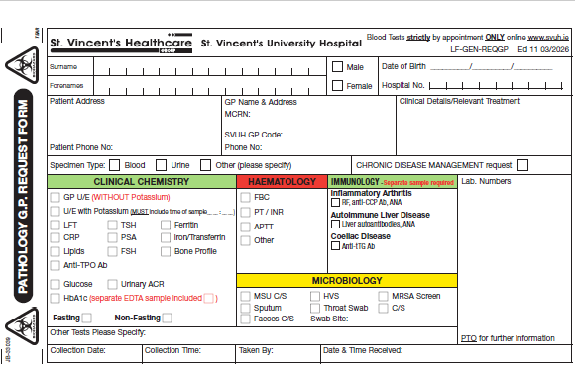

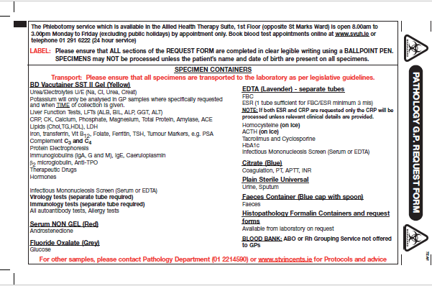
Please ensure that this form is PRINTED and FULLY COMPLETED by the GP before presenting to Phlebotomy. Electronic copies of this form cannot be accepted.

